Ponder User Guide

Version 1.0

November 18, 2019



Welcome to Ponder

RAN Dashboard User Guide

This user guide is designed to provide documentation for people who will use PONDER on a day-to-day basis. This document is designed to be read by any user of PONDER, as most users will have access to the features documented here.

About PONDER

PONDER is a dynamic dashboard that shows information about the Radio Access Network (RAN) capital plan in each market and region. The tool has been designed to help the teams communicate, manage, and drive the overall capital plan in their area of responsibility. The PONDER dashboard does the following:

* Provide common data set for all teams that work on the plan
* Show current stats of the plan and highlight areas that need focus
* Track key metrics and overall production against commitments
* Support the management of vendors and contracts
* Eliminate the need for regular reporting and provide automated charts/graphics

PONDER utilizes AXIOM which is directly connected to PACE (project management system), iPlan (project tracking system), and other system databases providing the ability to report real time status reports.

There are four main sections to the PONDER dashboard: Overview/Production, Build Your Own Cluster (BYOC), Data Slicer, and Daily Counts. Each section allows the user to filter to see only their region or market and is capable of drilling down to project level specifics.

Overview/Production Section

The focus of the Overview/Production section is to answer the question “what is the plan”.

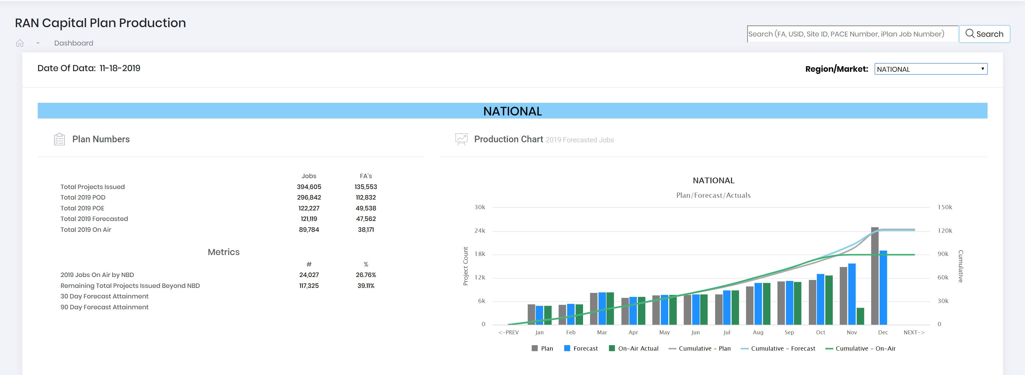

Figure 1.0 – Plan Overview

To begin, the user will select that Region/Market, located on the top right of the page. In this case the user has selected “NATIONAL” from the drop-down menu (red arrow) as the focus area. When the user selects the focus area, PONDER outputs a summary of the plan to the dashboard. Figure 1.0 is an example of what the user will see when the overview section is loaded. Located on the left side of the page, highlighted in red in Figure 1.0, is a summary of the overall plan. There the user will see:

* Total Projects Issued
  + Projects loaded in iPlan with a status of “Issued, In-Progress, or Complete”
    - Complete only includes projects completed in current calendar year (CCY)
* Total 2019 POD (Plan of Demand)
  + Projects that RAN has identified as needed for the CCY
  + Defined in iPlan with a Need by Date (NBD – “trigger date” of project) of the CCY
* Total 2019 POE (Plan of Execution)
  + Projects that are part of the official locked plan
  + Defined in PACE/iPlan with a Planned On Air Date of the CCY
* Total 2019 Forecasted
  + Projects that Construction has identified to be On Air by the end of the CCY
  + Defined in PACE/iPlan with an On Air Forecast Date of the CCY
* Total 2019 On Air
  + Projects that have been launched during the CCY
  + Defined in PACE/iPlan with an On Air Actual Date of the CCY
* Jobs
  + Projects that have been released/approved by RAN HQ
* FA’s
  + Unique site locations associated to the released/approved projects

Metrics were established to measure projects that have been released into service. Those metrics are:

* 2019 Jobs On Air by NBD
  + Projects that have an On Air Actual Date on or before the Need By Date
* Remaining Total Projects Issued Beyond NBD
  + Projects that are not On Air that exceed the NBD
* 30 Day Forecast Attainment
  + Compares what was forecast to be On Air over the past 30 days vs the number of projects that were launched during those 30 days
* 90 Day Forecast Attainment
  + Compares what was forecast to be On Air over the past 30 days vs the number of projects that were launched during those 30 days

On the right side of the page, the user will see a production chart for the jobs that are forecast to be On Air within the calendar year (Figure 1.1).

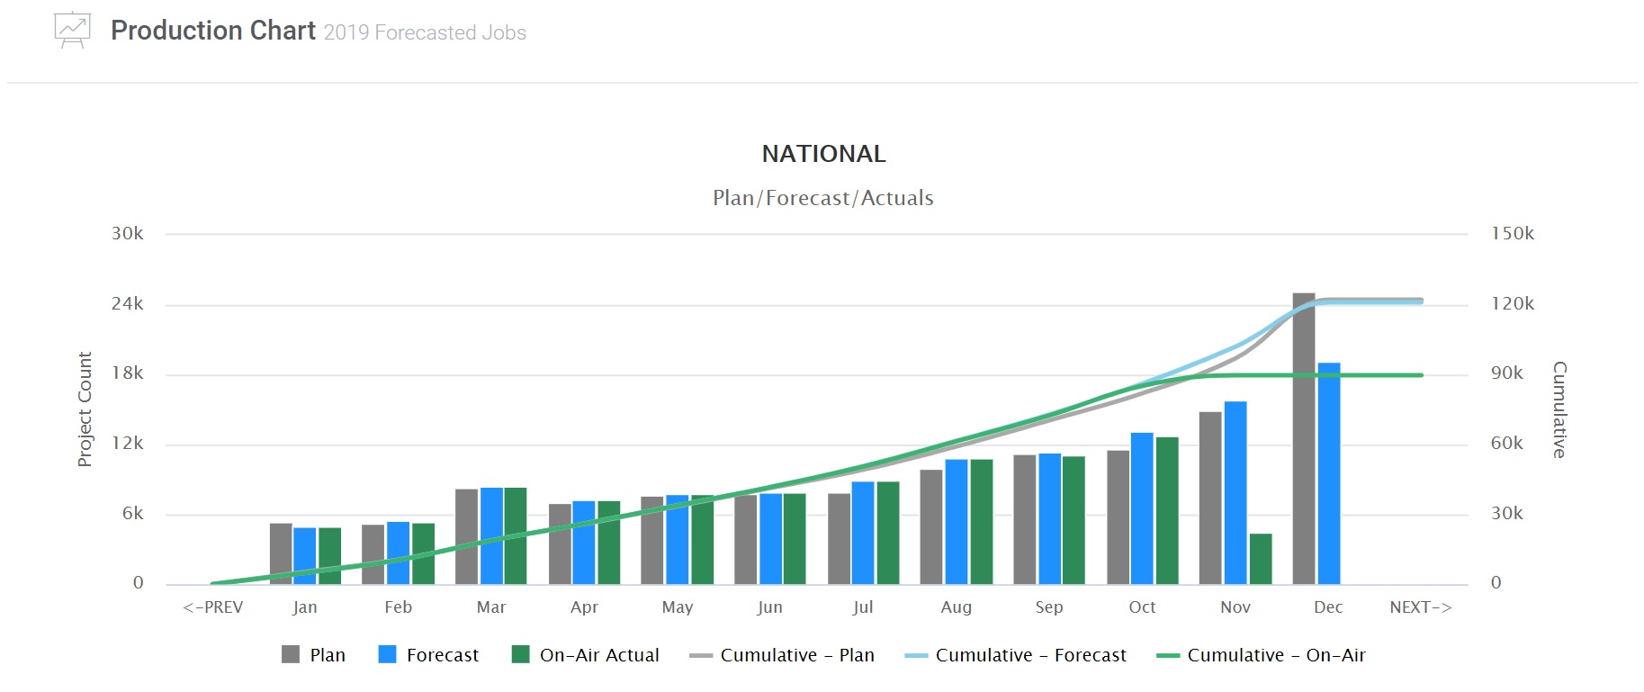

Figure 1.1 – Production Curve

The interactive chart allows the user to select the information to be displayed. The user can toggle a series on or off by clicking the series label located in the legend. Production details will also display by hovering the mouse on data points located on the chart (Figure 1.2).

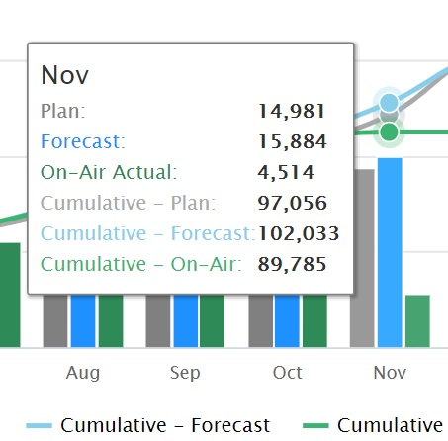

Figure 1.2 – Production Detail

The series within the production chart are defined as:

* Plan
  + Date Construction originally estimates the project will go into service
    - Date can only be updated through the change control process
* Forecast
  + Date Construction believes the project will go into service
    - Date can be modified for accuracy throughout the project life cycle
* On-Air Actual
  + Date the project goes into service
    - Date is set when the project is launched for commercial service

The next portion of the overview/production section provides additional details of the plan regarding program status and market details (Figure 1.3). Here the plan is broken down by year and by product type. The default view for this portion is the current working year but the user can review the previous year’s results or look at future year’s details by simply clicking the year of interest. PONDER breaks the overall section into 6 main program groups:

* New Site Build
  + Capacity
  + Coverage
  + License Protect
  + Merger and Acquisition (M&A)
  + FirstNet
  + High Rent Relocation (HRR)
  + Wireless Local Loop (WLL)
* Macro Carrier Add (MCA)
  + 4TXRX (4-way transmit/receive) – new hardware (antenna etc.) required
  + 5GNR (new radio to support 5G services)
  + Bandwidth Expansion – Hardware (BWE HW)
  + FirstNet Additional Carrier (FN AC)
  + LTE Additional Carrier (LTE AC)
  + 4TXRX Software
  + MCA BWE Software
  + Software Carrier
* Centralized Radio Access Network (CRAN)
* Overlay
  + LTE 1C
  + WLL
* In-Building
  + DAS Modification
  + Additional Carrier
  + LTE Overlay
  + Neutral Host Tennant Add
  + New Site
  + Small Cell
* Bandwidth Expansion Software (BWE SW)

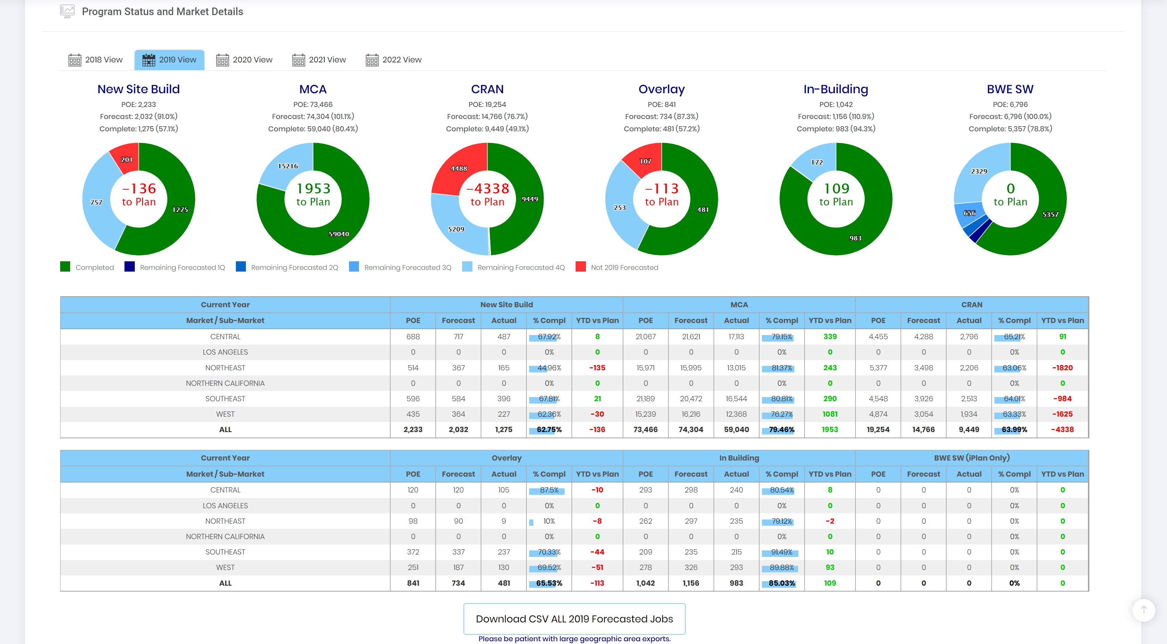

Figure 1.3 – Program Status and Market/Sub-Market Details

POE counts reflect the number of projects that were part of the official plan whereas Forecast counts reflect what Construction is forecasting to have on the air by the end of the year. Complete counts reflect the number of projects that are transmitting commercially. The donut charts highlight what has been completed, the quarter in which the projects are forecast, the difference between the POE and forecast plan, and production related to the plan. Market/Sub-Market details for each program type are broken down in the subsequent tables.

Users are provided the ability to get additional details of each program type. Clicking on the Program type (i.e. New Site Build) will open a new Drilldown page (Figure 1.4).

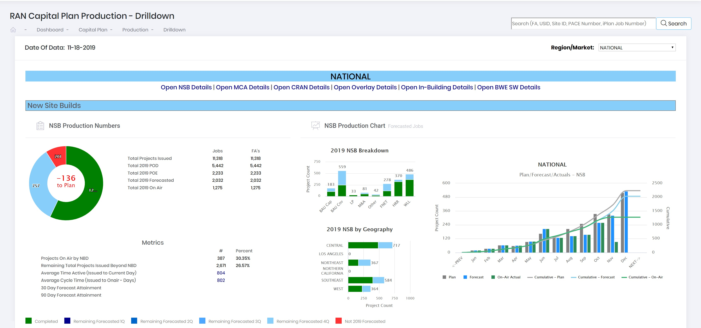

Figure 1.4 – Drilldown Summary

Similar to the summary view of the Overview/Production section, the Drilldown view highlights the overall plan and production levels. Additional metrics were added to capture Average Time Active (Issued to Current Day) and Average Cycle Time (Issued to On Air – Days). These metrics are used to show the project life cycle. Bar charts highlighting the type of NSB (Capacity, Coverage, etc.) and where (market/sub-market) the projects are located. The charts are interactive and will display additional details by hovering the mouse over the individual bar.

PONDER provides a summary (Figure 1.5) of key milestones which a relevant to the project life cycle:

* Preliminary RF Data Sheet (p-RFDS)
* Final RF Data Sheet (f-RFDS)
* Site Acquisition Complete (SAQ Comp)
* Construction Start (Const Start)
* Tower Top Complete (T Top Comp)
* Construction Complete (Const Comp)
* On Air

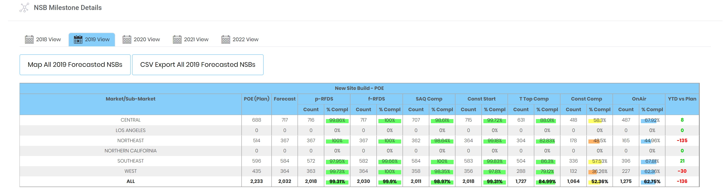

Figure 1.5 – Milestone Summary

As with the main Overview/Production, project counts related to POE, Forecast, and Completion is displayed for the different programs associated with the product group (Figure 1.6).

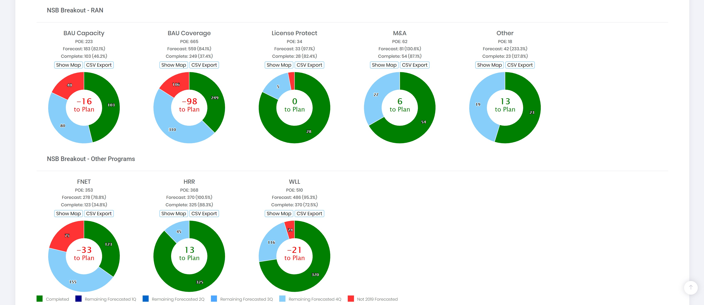

Figure 1.6 – Program Production

An added feature to the Drilldown section is a mapping feature. Users can access the mapping feature by clicking the button, denoted by the red arrows in Figures 1.5 and 1.6, which will open an interactive map in a secondary window (Figure 1.7). Project status and locations are displayed inside the mapping window. Users can zoom in and out of areas of interest or turn off layers through the layer management menu (highlighted by red square). Specific projects details can be accessed by clicking on an individual project within the map. Project and quarterly forecast counts are displayed in a table on a Market/Submarket level.

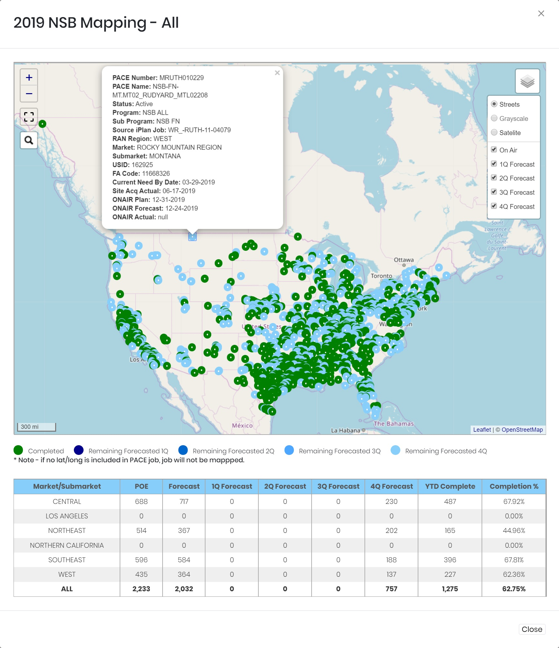

Figure 1.7 – Product Group Map

A critical step in the project life cycle is Site Acquisition (SAQ). Until this milestone is complete, work on the project is stalled. The Drilldown section provides a summary view (Figure 1.8) of how many projects are in the POE, Forecast, and how many are Site Acquisition Complete (RE020). PONDER also highlights when SAQ is forecast to be completed relative to the On Air Forecast. This information can be used to highlight projects that can be pulled in or projects at risk of being pushed out.

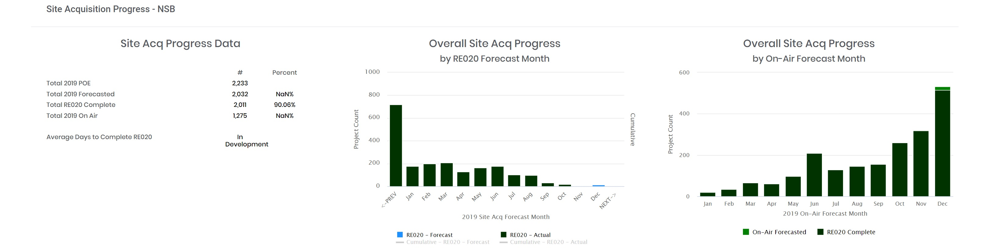

Figure 1.8 – SAQ Summary

The final piece of the Drilldown section is a Task Progression summary. Each project type has key milestones that must be completed to ensure that they can be commercially released into service. PONDER pulls Task Progression Details from the PACE database and displays the results in a bar chart (Figure 1.9).

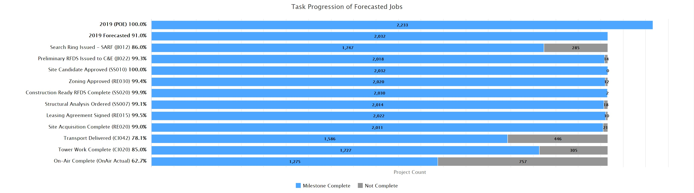

Figure 1.9 – Task Progression Summary

Users can cycle between the different program groups by selecting the program details at the top of the Drilldown page (Figure 1.10) or through the accordion tabs (Figure 1.11).



Figure 1.10 – Program Selection

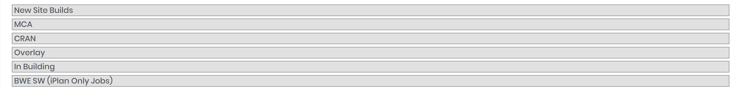

Figure 1.11 – Program Accordion Selection

An additional feature within the Overview/Production is the ability to search based off FA, USID, Site ID, PACE Number, or iPlan Job Number. The user enters the search criteria in the text field located at the top right of the page (Figure 1.12).



Figure 1.12 – Search Function

The dashboard returns site details as well as a list of projects that have taken place at the site over the past two years. Projects that have been commercially launched are highlighted in green and active projects are highlighted in grey. PONDER also provides the ability to export the project data via CSV or Excel file. Figure 1.13 is an example of the search feature output.

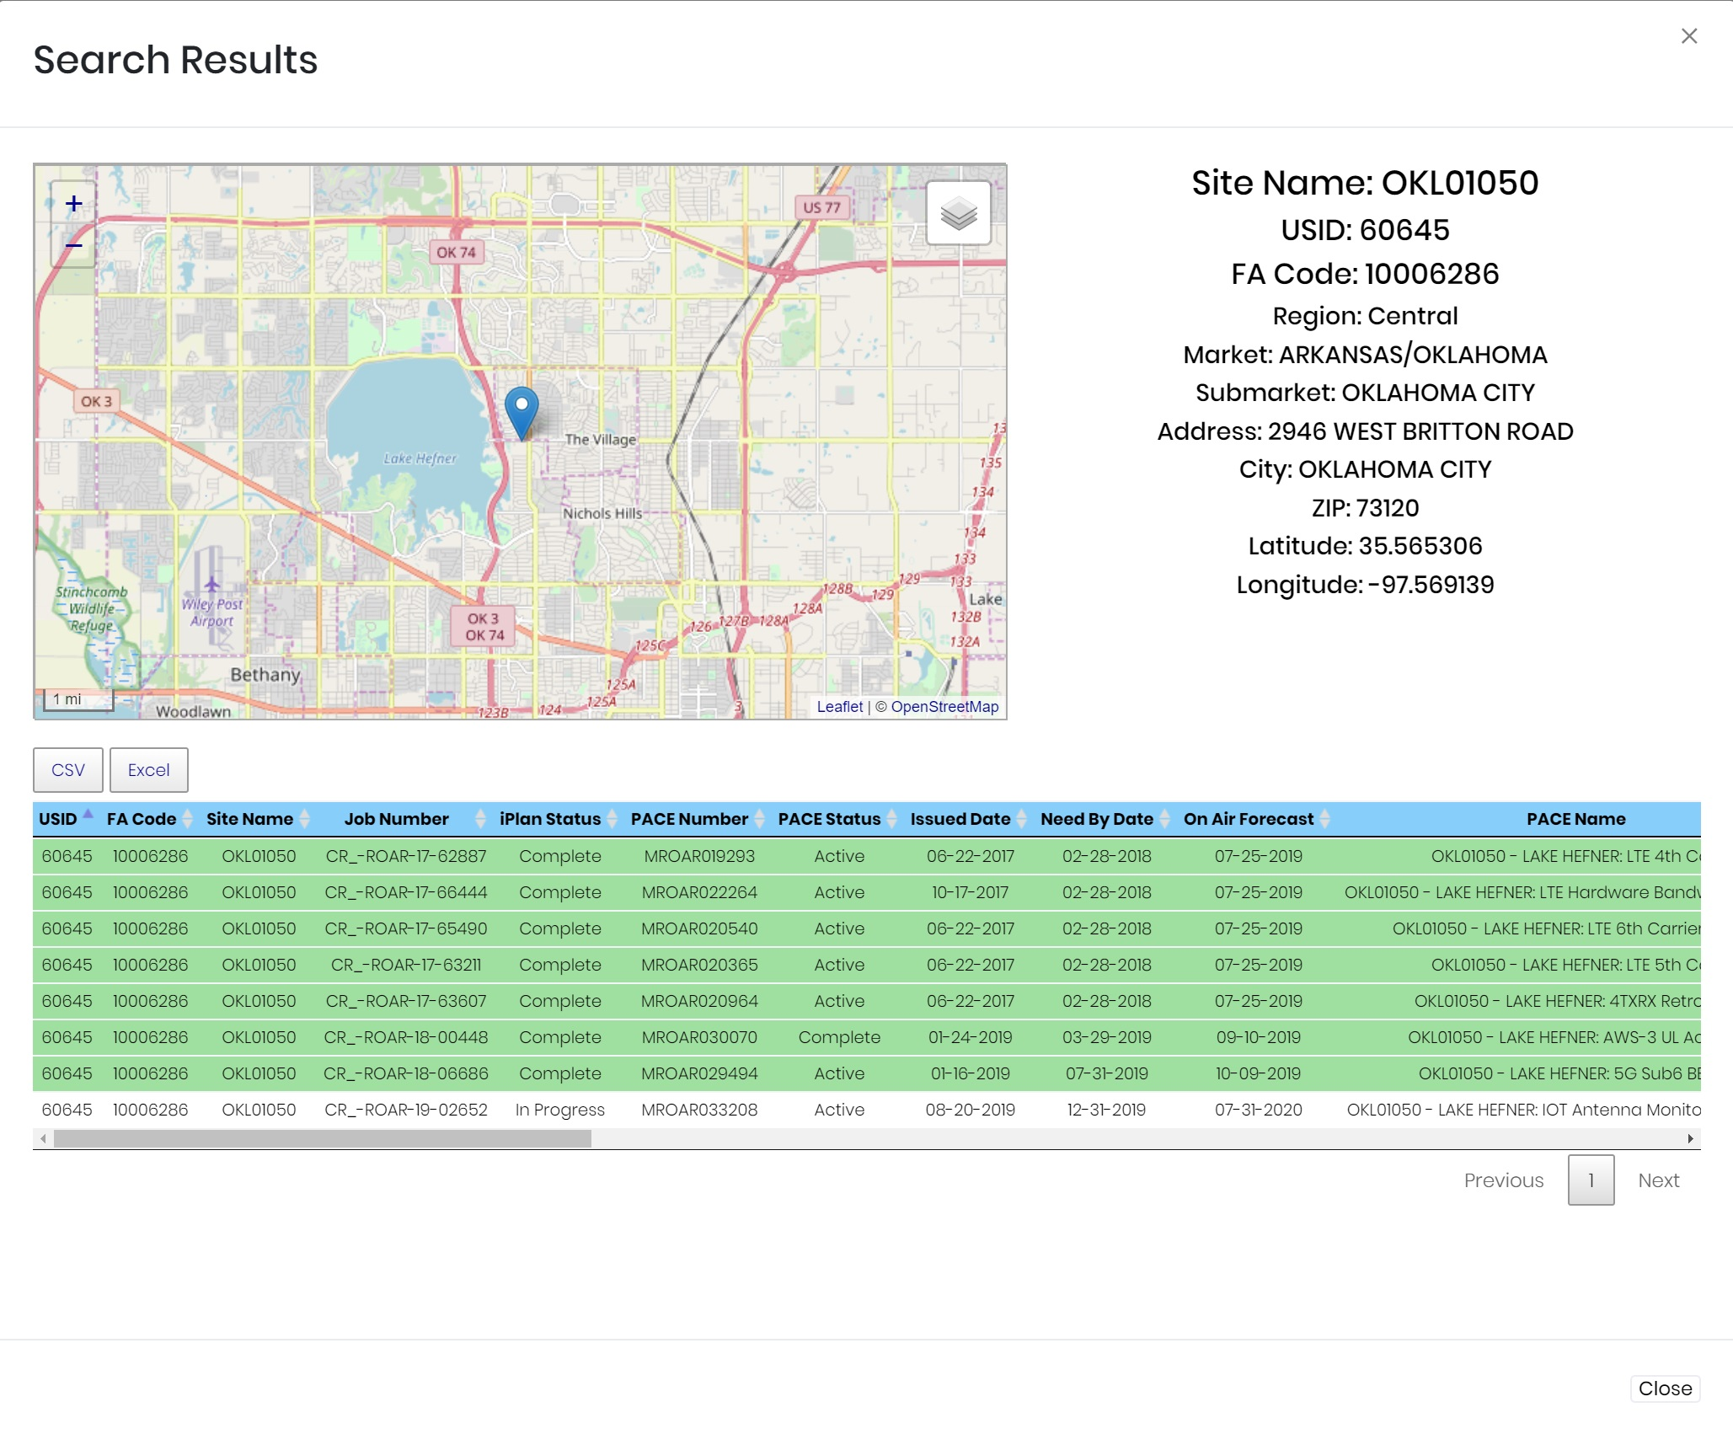

Figure 1.13 – Search Results

Build Your Own Cluster

The Build Your Own Cluster (BYOC) section allows the user to create customized cell site clusters. Once the clusters are created, they can be used to track projects in a targeted area utilizing the Data Slicer. Users access the BYOC section by selecting it from the menu located on the left-hand side of the main dashboard page (Figure 2.0).

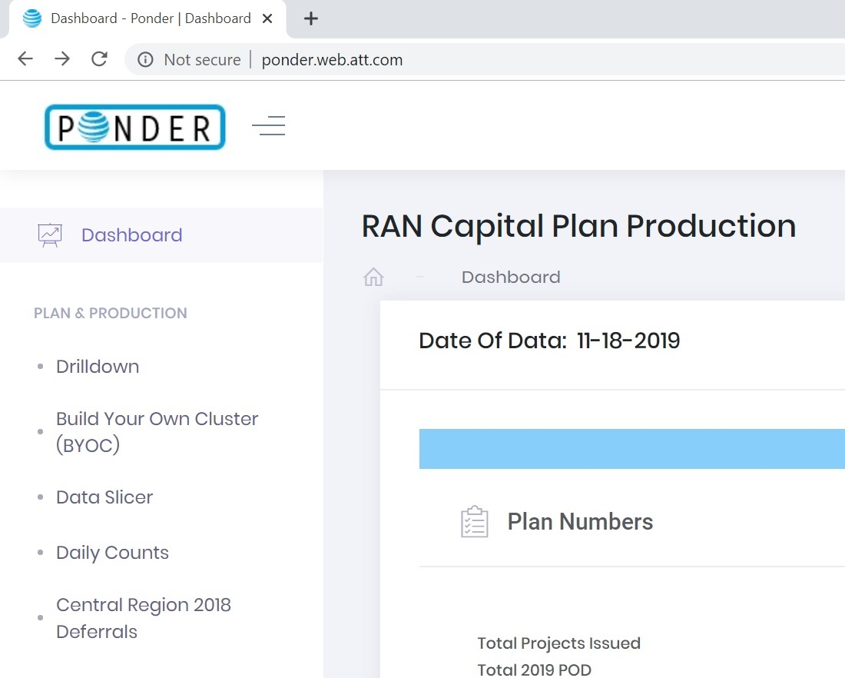

Figure 2.0 – BYOC Section

To create a cluster, the user can select the market of interest from the dropdown menu denoted by red arrow in Figure 2.1. Once the market is selected, the Source List will be updated with site information (FA_CODE, USID, and SITE_NAME) for every location an iPlan project has been created for within that market.

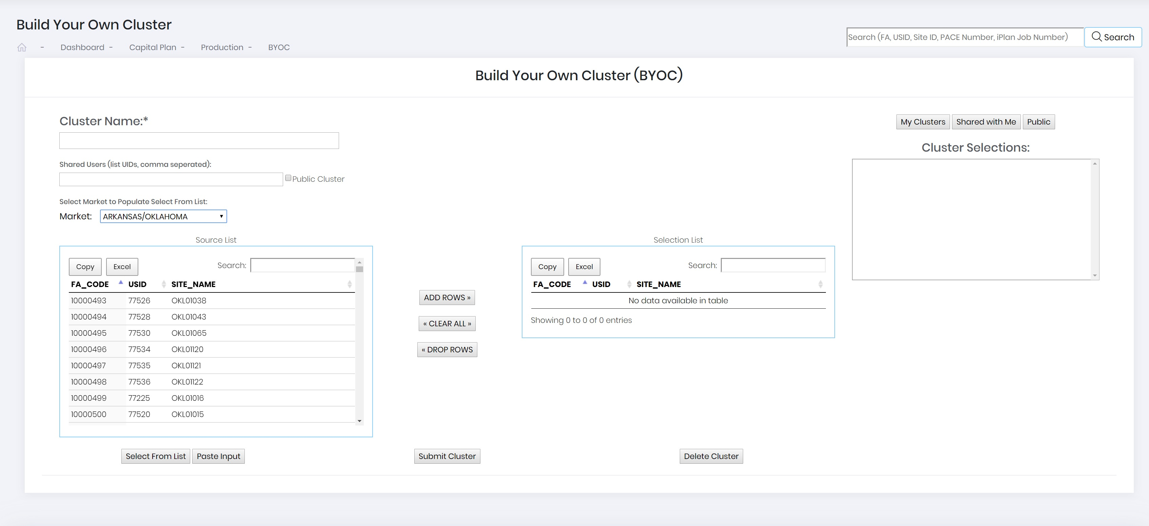

Figure 2.1 – BYOC Market Selection

From the Source List users can select the individual locations they would like to be part of the cluster. Users simply highlight the site and then click on the “ADD ROWS” button. The site will then be added to the “Selection List”. The “Search” feature allows the user to find a location within the “Source List” by entering either the FA_Code, USID, or Site_Name. Users can also select multiple locations from the Source List by holding the “CTRL” Key while making the selections and then clicking on “ADD ROWS”. Figure 2.2 highlights the addition of multiple locations to the “Selection List”.

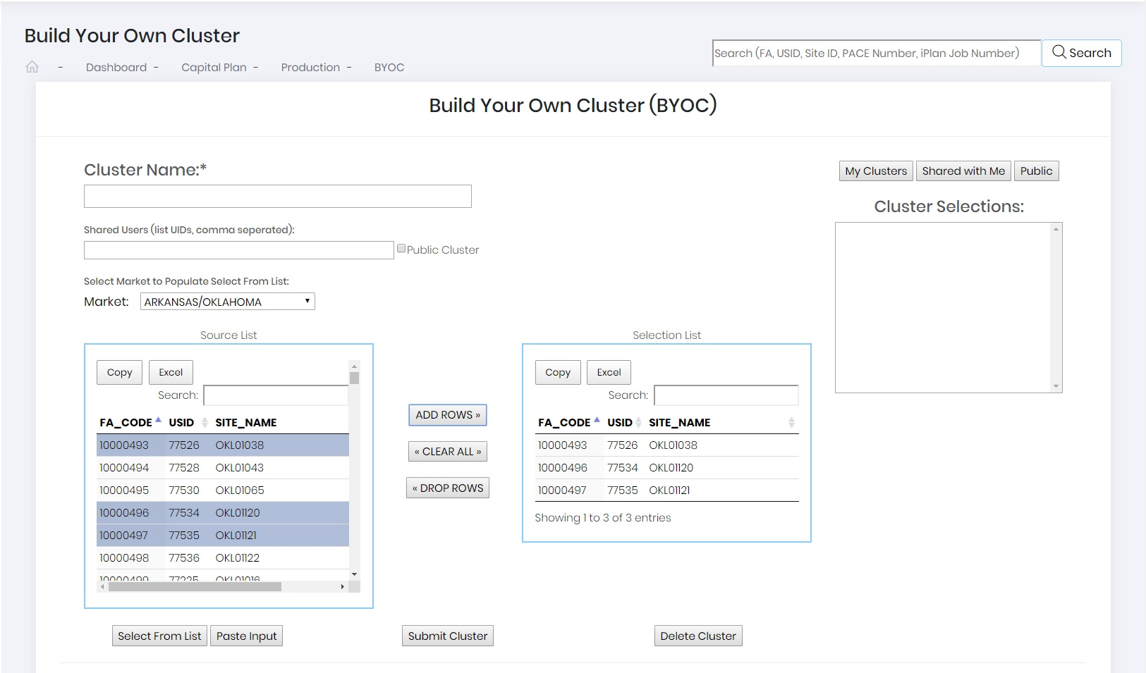

Figure 2.2 – Multiple Selection

Users can also select the “Paste Input” button (Figure 2.3) as an additional way to create a cluster. This feature allows the user to populate the source list by typing or pasting in a list of locations using either the FA_CODE, USID, or SITE_NAME. After populating the “Source List” with the desired locations, users can then add the locations to the “Selection List” by clicking the “ADD ROWS” button. Locations can also be removed from the “Selection List” by selecting the location and then clicking the “DROP ROWS” button.

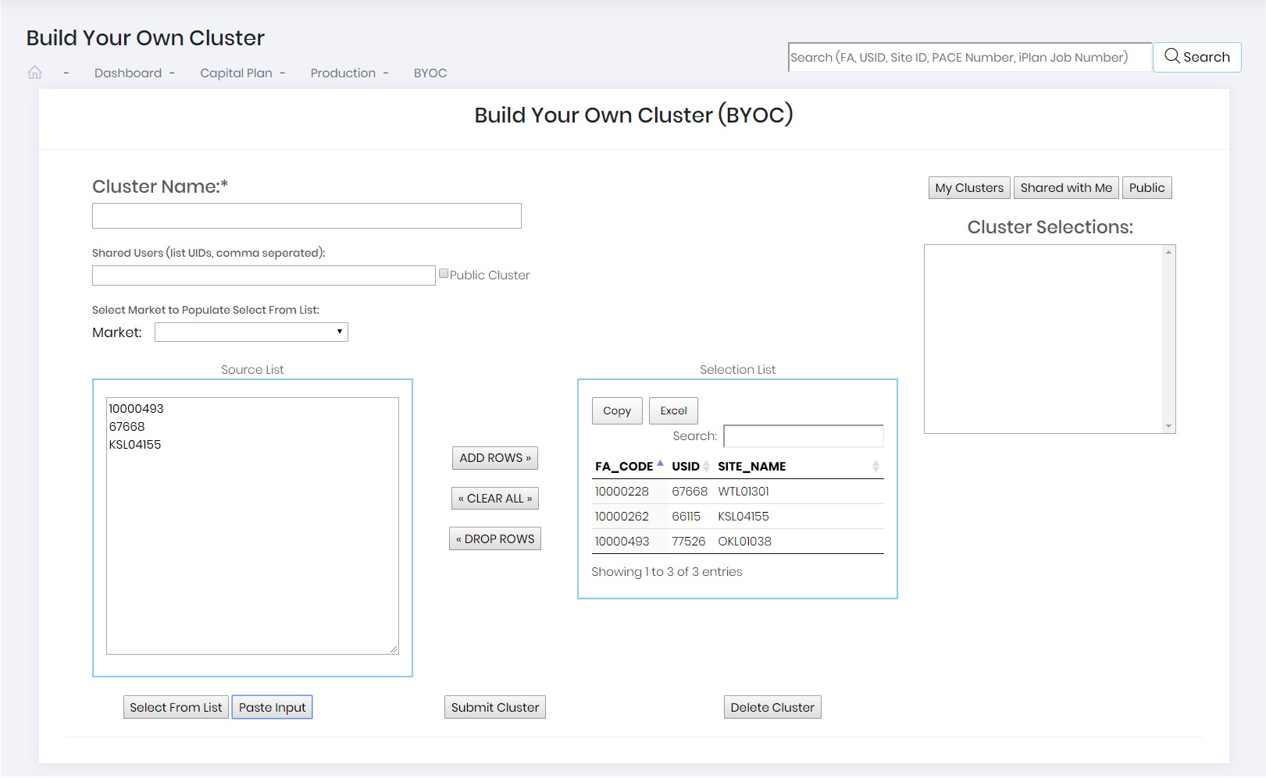

Figure 2.3 – Paste Input

Once the “Selection List” is finalized, the user will populate the “Cluster Name”. Users can keep the cluster private (appear in “My Clusters”), share the cluster with a list of other users, or make the cluster “Public”. Users simply populate the “Shared Users” with an ATTUID separating each user with a comma to share the cluster or select the “Public Cluster” box to make it public. To complete the creation of the cluster, the user must click the “Submit Cluster” button. An “Insert Complete” message (Figure 2.4) will confirm the cluster creation.

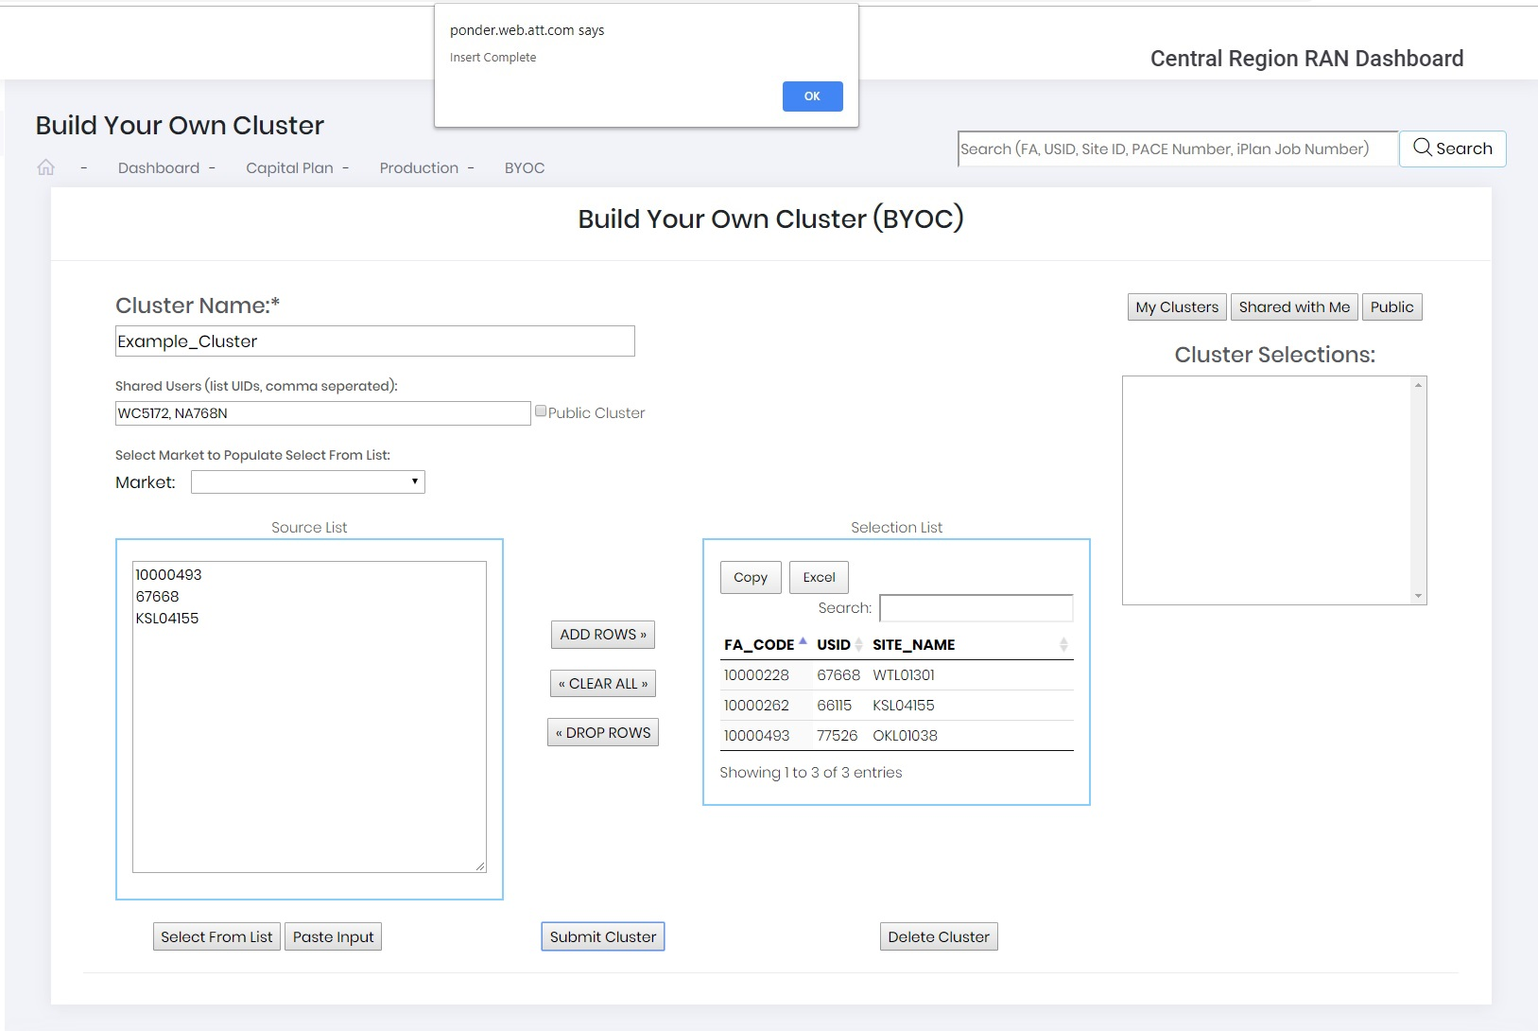Figure 2.4 – Insert Complete Message

Click the “OK” button and the new cluster will appear in the “Cluster Selections” field (Figure 2.5).

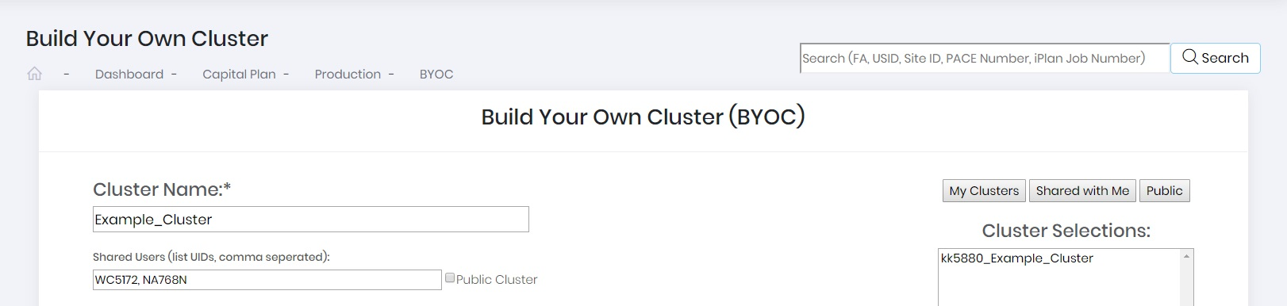

Figure 2.5 – Example Cluster

Clicking on the “My Clusters”, “Shared with Me”, or “Public” buttons will populate the “Cluster Selections” with a list of clusters that are available to the user. When the user selects a cluster from the list, the “Selection List” will be populated with a list of locations that are part of the cluster. The list of locations can be exported to an Excel file by clicking the “Excel” button or copied to the clipboard by clicking the “Copy” button.

Data Slicer

The Data Slicer section allows the user to explore specific build plan details through the application of filters. The filters are:

* Forecast Year
  + Ability to select previous year through future forecast years
* Region
  + Four RAN Regions – Central, Northeast, Southeast, and West
* Market
  + 26 RAN Markets
* Submarket
  + Each submarket associated with the 26 RAN Markets
* Program
  + Product Group Types (i.e. CRAN, NSB, MCA, etc.)
* Sub-program
  + Sub Product Groups (i.e. 4T4R, 5G NR, CRAN Node, etc.)
* Civil Vendor
  + Turf Vendor responsible for completing the project
* Site Acquisition Vendor
  + Turf Vendor working the site acquisition portion of the project
* RAN Driver
  + Initiative the project is intended to solve (i.e. FirstNet, WLL, License Protect, etc.)
* BYOC
  + Clusters users built in the BYOC Section (My Clusters, Shared, or Public)

Users access the Data Slicer section by selecting it from the menu located on the left-hand side of the main dashboard page (Figure 3.0).



Figure 3.0 – Data Slicer Section

To begin, the user will select the filters to apply. In this case the user has not applied any filters. Once all the desired filters have been selected the user will click the “Submit” button. PONDER outputs a summary of the plan to the Data Slicer. Figure 3.1 is an example of what the user will see when the filter section is loaded.

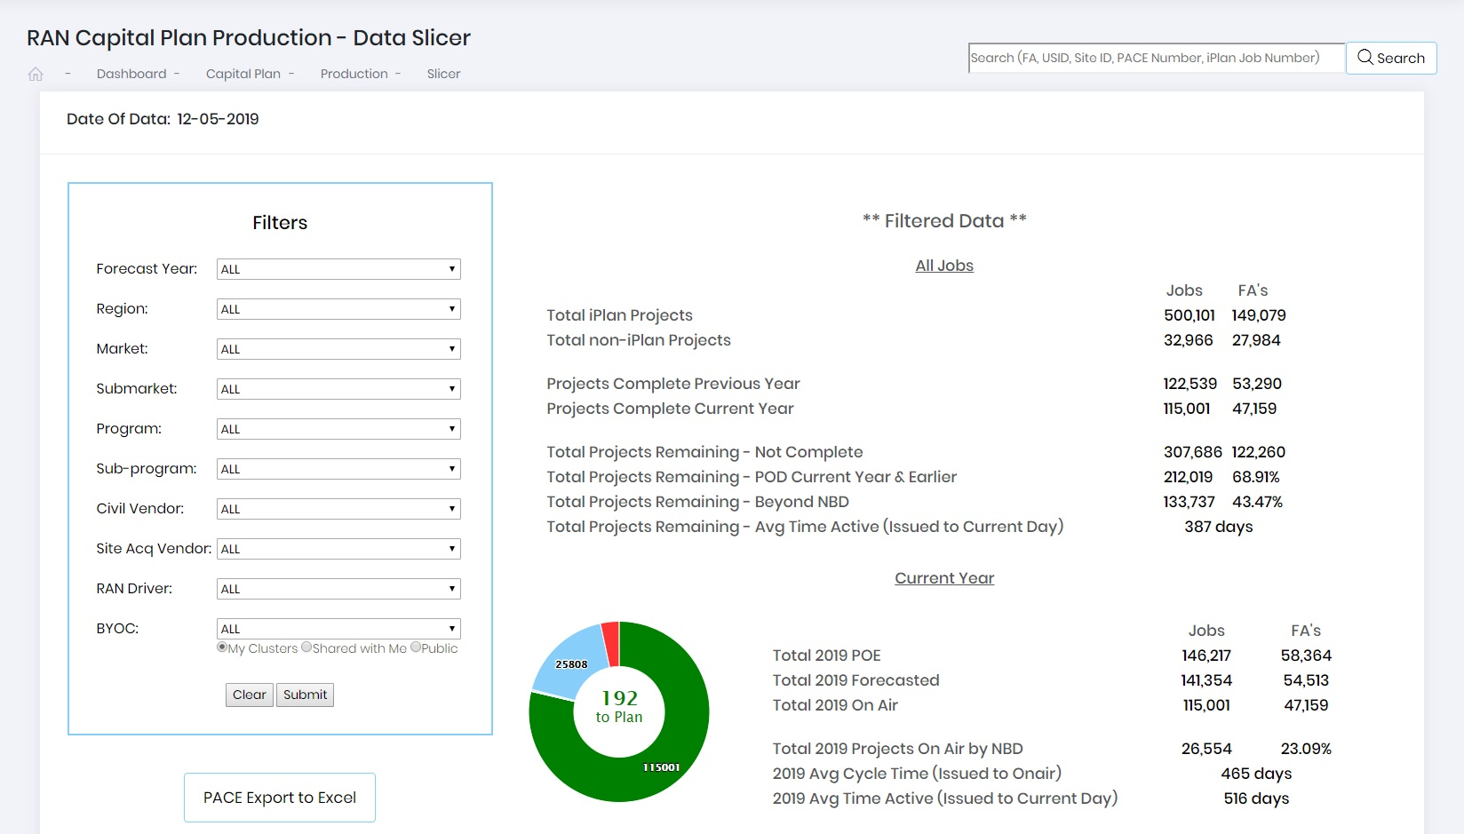

Figure 3.1 – Data Slicer

Located on the right side of the page is a summary of the filtered data by project count and unique FA Locations associated to those projects:

* Total iPlan Projects
  + Projects loaded in iPlan with a status of “Issued, In-Progress, or Complete”
* Total non-iPlan Projects
  + Projects loaded in PACE that do not require an iPlan Project (ETTCS, SIAD, etc.)
* Projects Complete Previous Year
  + References the number of projects associated to the filter completed last year
* Projects Complete This Year
  + The number of projects that have been completed in current calendar year (CCY)
* Total Projects Remaining – Not Complete
  + The number of projects remaining to be completed
* Total Projects Remaining – POD Current Year & Earlier
  + The number of projects remaining to be completed that have a Plan of Demand date of the current year or earlier
* Total Projects Remaining – Beyond NBD
  + The number of projects remaining where the Need by Date has passed
* Total Projects Remaining – Avg Time Active (Issued to Current Day)
  + The average number of days each remaining project has been issued

Further down in the summary, the user will see project data specific to the current year:

* Total 2019 POE
  + The number of projects that are in the Plan of Execution
* Total 2019 Forecasted
  + The number of projects with a On Air Forecast Date in the current year
* Total 2019 On Air
  + The number of projects that have been released for commercial service
* Total 2019 Projects On Air by NBD
  + The number of projects that were completed before the Need by Date
* 2019 Avg Cycle Time (Issued to On Air)
  + The average number of days it took to get a project On Air
* 2019 Avg Time Active (Issued to Current Day)
  + The average number of days each remaining project has been issued

Also included in the current year summary is an interactive doughnut chart. This provides a view of how many projects are on air (Green), Remaining (Blue), difference between POE and Forecast (Red), and progress against the On Air Plan. The plan details will display by hovering the mouse over the doughnut chart (Figure 3.2).

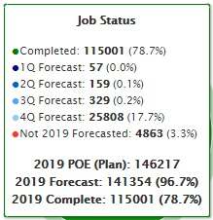

Figure 3.2 – Doughnut Chart Details

Users can export a list of additional details associated to the filtered selection by clicking the “PACE Export to Excel” button located below the “Filters”.

Below the summary are a series of tabs that can be selected to get additional information related to Job Count Breakdowns, Milestone Progress, Production Charts, Aging, Milestone Forecast Changes, RE020 Cycletime (Site Acquisition), and Recent/Upcoming projects.

Job Count Breakdown

The “Job Count Breakdown” tab highlights the projects associated with the filters the user selected. Users can select the subsequent tabs (Year, Region, Market, Submarket, Program, Subprogram, Civil Vendor, Site Acquisition Vendor, or RAN Driver) to produce interactive bar charts and tables. Figure 3.3 is an example of the data that will be displayed when selecting “Region” tab.

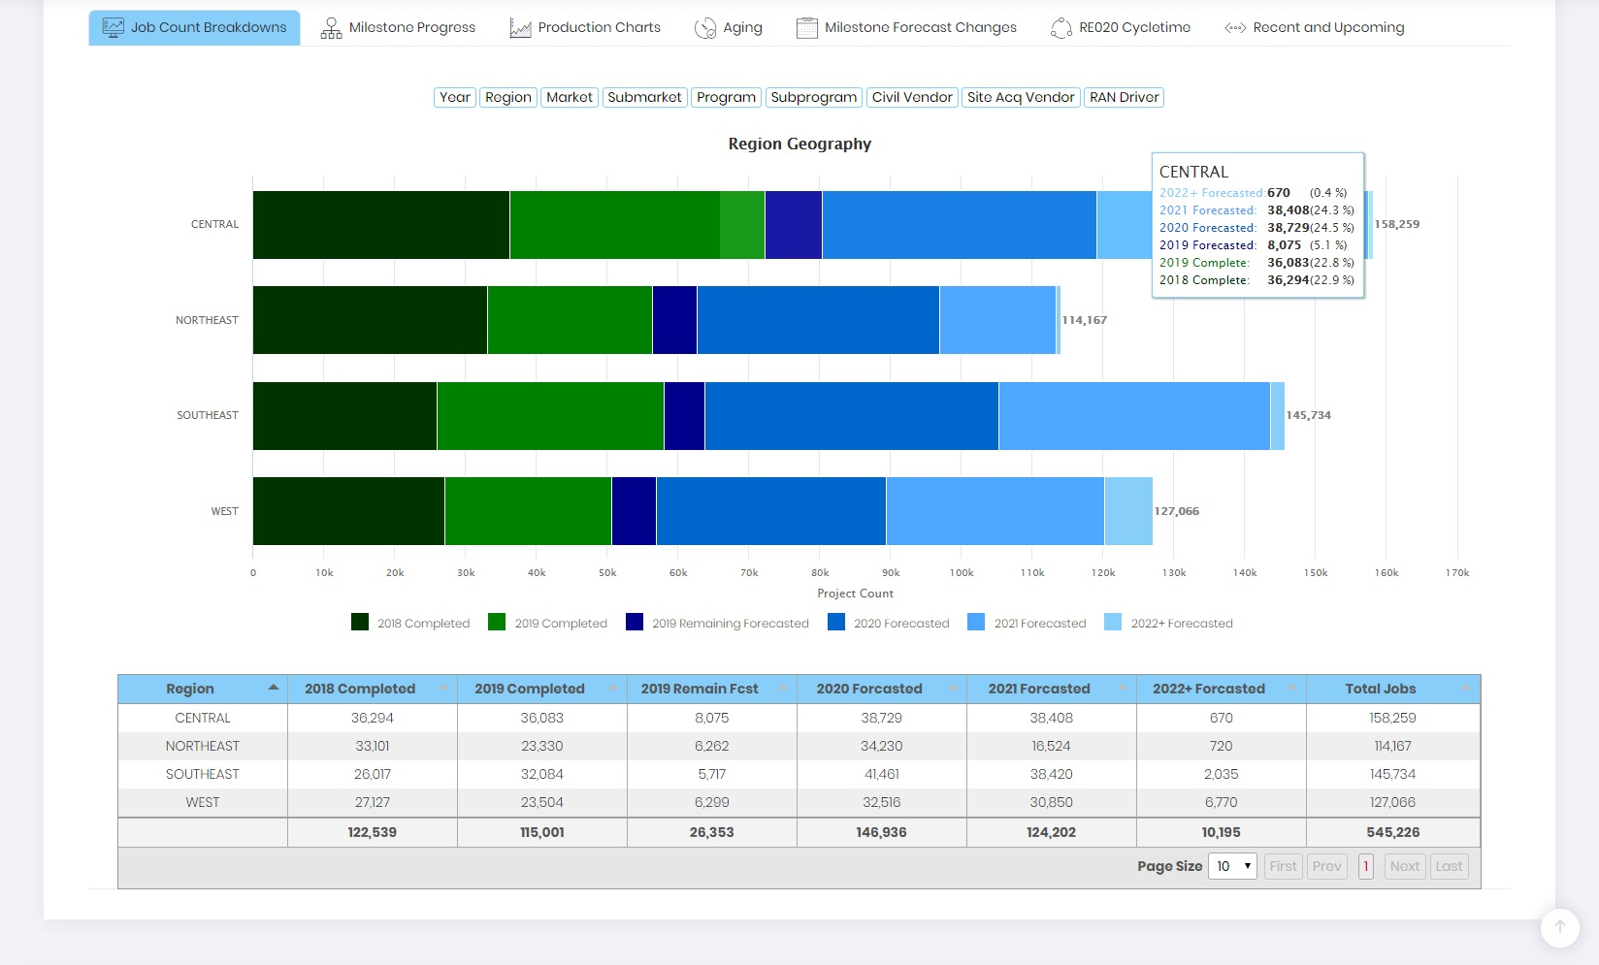

Figure 3.3 – Job Count Breakdown by Region

The Bar Chart highlights the number of projects associate to each region by Forecast Year. Users can get additional data by hovering over the bar chart. Below the bar chart is a table view of the filtered data. The bar chart and table will update as the user selects a different tab.

Milestone Progress

The “Milestone Progress” tab is used to track key task progressions of each program. The user will select the Program of interest, in this case the user has selected “NSB ALL”, from the drop-down menu (red arrow). PONDER then outputs an interactive stacked bar chart that highlights the progress of key milestones associated to that program (Figure 3.4).

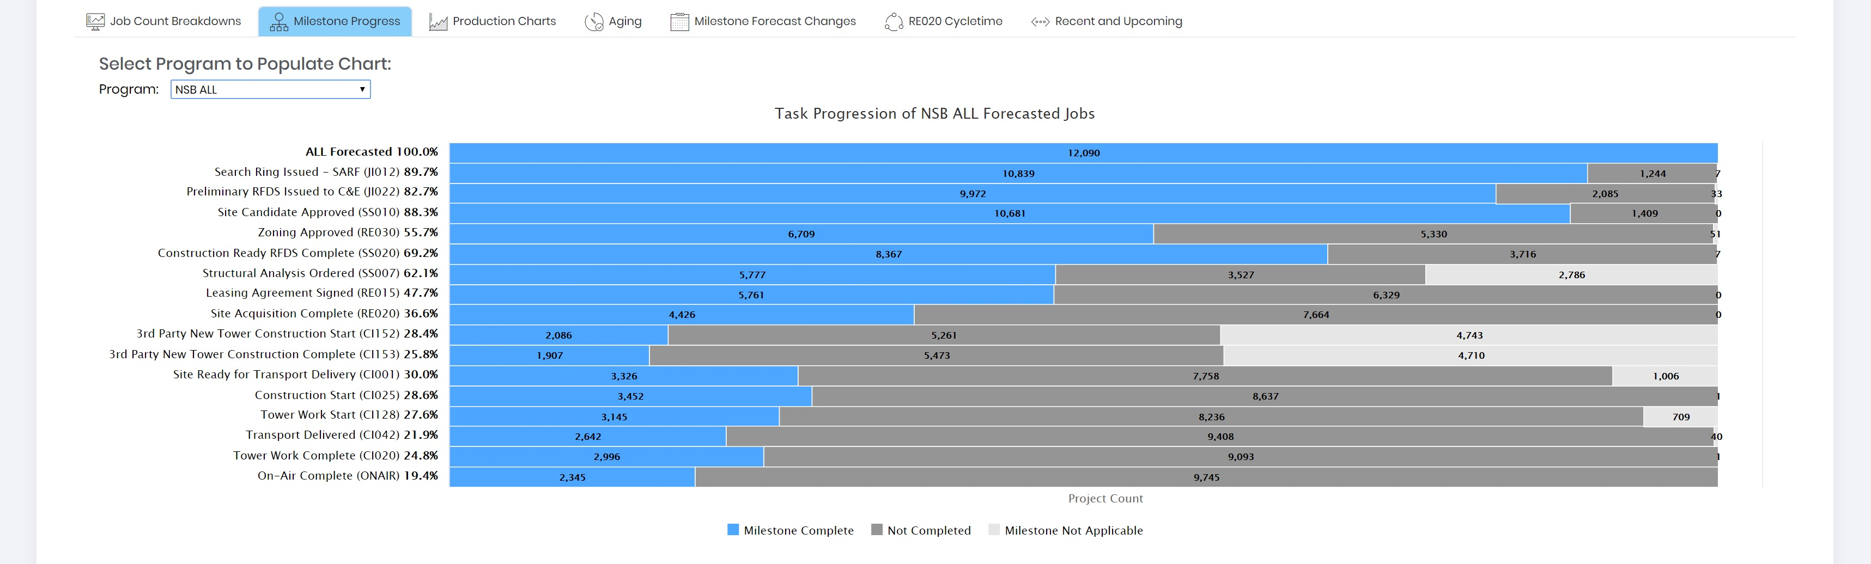

Figure 3.4 – Milestone Progress (NSB ALL)

Detailed project information can be exported by clicking on the bar chart. For example, if the user wanted to know the projects that don’t have a “Site Candidate Approved (SS010)” they would click on the gray portion of the bar chart (red square). This would export a .csv file containing detailed information on the 1,409 jobs that have not yet completed the milestone. In addition to the bar chart, a column chart is output that highlights the status of milestone tasks that have not yet completed (Figure 3.5).

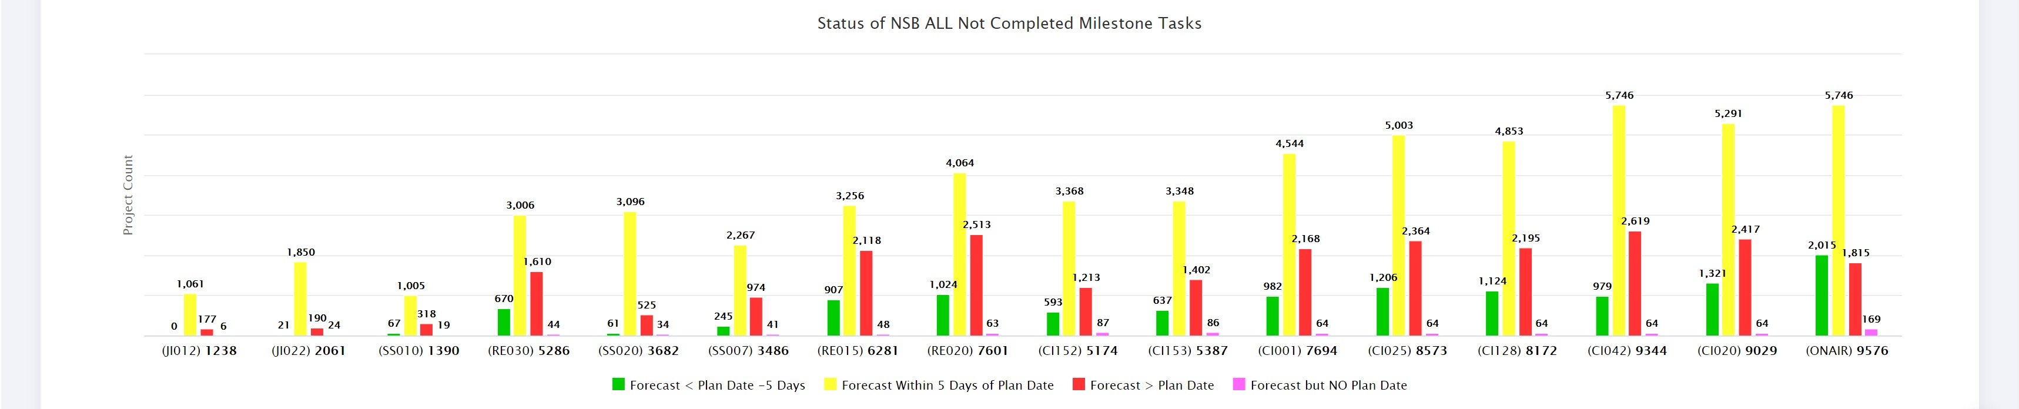

Figure 3.5 – Milestone Status (NSB ALL)

The chart identifies where the forecast of each major milestone falls with regard to the planned date. Projects with a forecast milestone date at least 5 days earlier than the planned date are displayed with a green column. The column is yellow for jobs that have a forecast milestone date within 5 days of the planned date. Jobs that exceed the planned date are captured in the red column and those jobs that are forecast but don’t have a planned date are displayed with a magenta column. This is very useful to identify at risk projects.

Production Charts

Plan/Forecast/Actual production curves are captured in the “Production Charts” tab. The user will select the Program of interest, in this case the user has selected “NSB ALL”, from the drop-down menu (red arrow). PONDER then outputs an interactive stacked bar chart that highlights the production curves of that program (Figure 3.6).

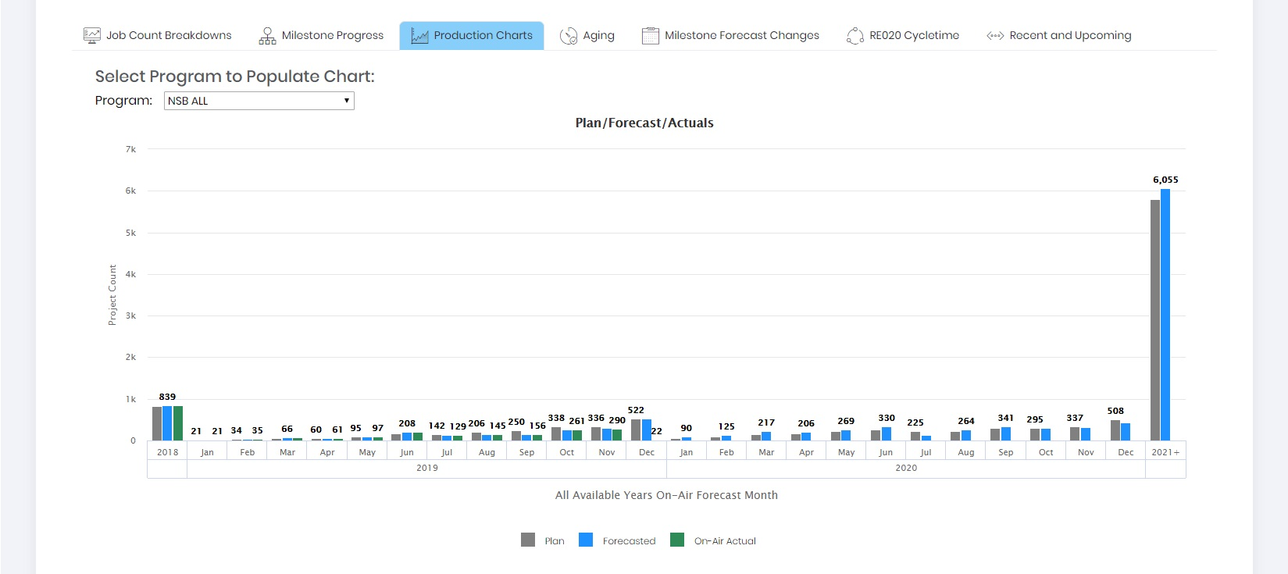

Figure 3.6 – Production Curve (NSB ALL)

Aging

The “Aging” tab is useful to see how many days it takes between Actualized Milestones (completed) and Unactualized Milestones. This tab can help identify jobs that have potentially become stale. To begin the user will select the “Program” of interest, “Actualized Milestone”, and a corresponding “Unactualized Milestone” from the drop-down list. In this case the user has selected “NSB ALL” as the program of interest, “Site Acquisition Complete (RE020) as the actualized milestone, and “Construction Started (CI025) as the unactualized milestone. Figure 3.7 highlights how many days the NSB projects have been Site Acquisition Complete but have yet to start construction.

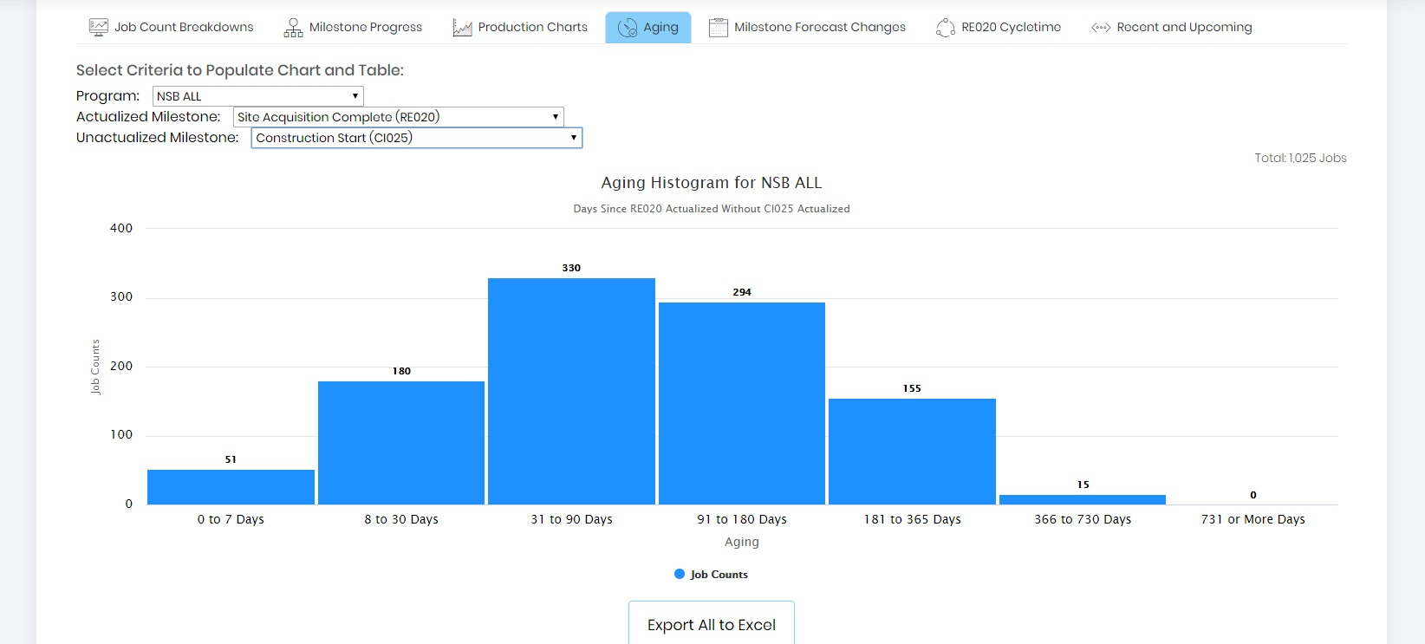

Figure 3.7 – Aging

Users can get detailed information of the graph by clicking on the bar of interest. An Excel file will be exported of the individual jobs related to that bar. Users can also export the entire list of jobs by selecting the “Export All to Excel” button.

The data is also displayed in an interactive table below the graph (Figure 3.8), starting with the longest period to the shortest. Users can sort the data by selecting the category at the top of the table or can filter on select criteria at the base of the table (red square).

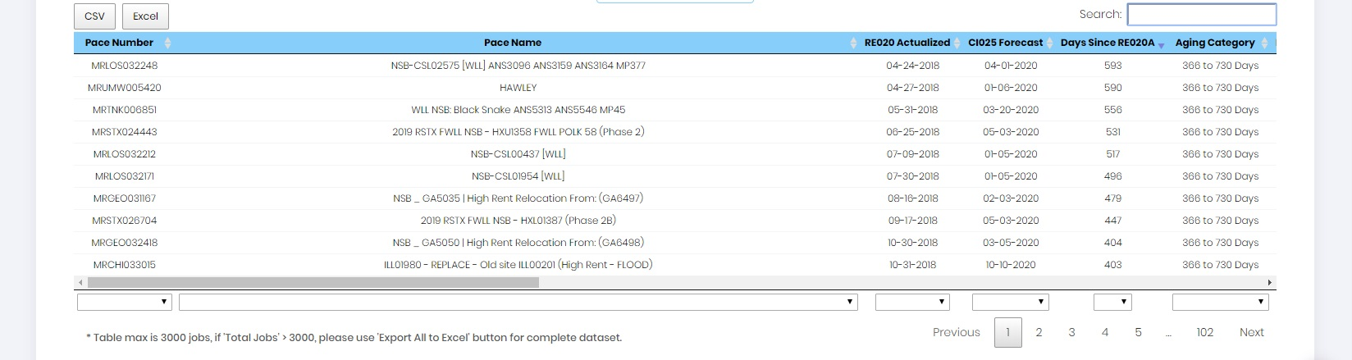

Figure 3.8 – Aging Table

Milestone Forecast Changes

The “Milestone Forecast Changes” tab allows users to review how many changes have been made regarding milestone forecasts over a selected period. Users will select the milestone of interest (red arrow), whether to limit the data to the forecast date changes where the YEAR changes, and the number of days to review. Once the selections have been made, a bar chart highlighting the histogram of changes is generated. Projects that have been pulled in will have a negative value whereas projects that have been pushed out will have a positive value. Figure 3.9 shows an example of the bar chart highlighting the number of changes made to the “On-Air Complete” forecast over the last 5 days.

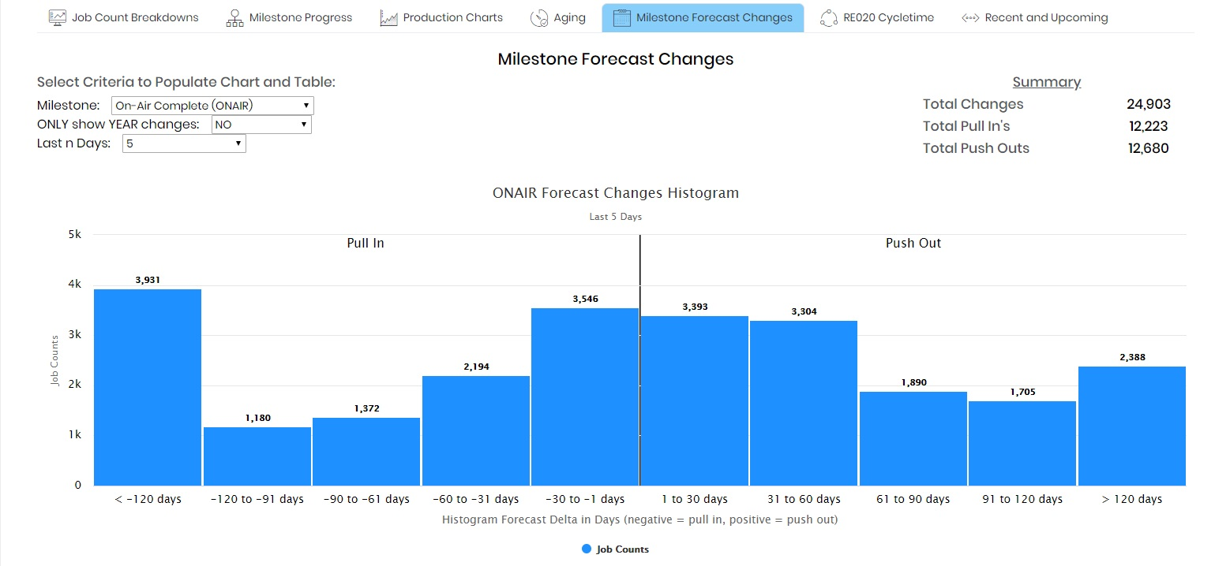

Figure 3.9 – Milestone Forecast Changes

Similar to the “Aging” tab, the data is also displayed in an interactive table below the graph (Figure 3.10), starting with the longest period to the shortest. Users can sort the data by selecting the category at the top of the table or can filter on select criteria at the base of the table.

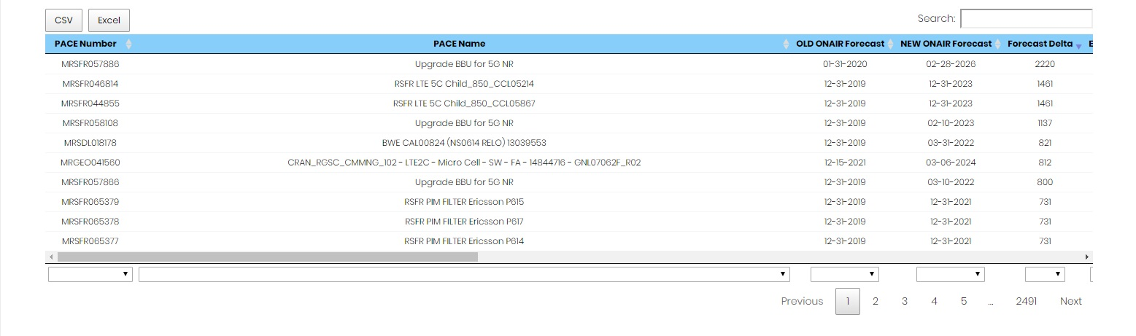

Figure 3.10 – Milestone Forecast Changes Table

RE020 Cycletime

The “RE020 Cycletime” tab highlights the length of time (days) it has taken for each project to reach Site Acquisition Complete (RE020). When the “RE020 Cycletime” tab is selected, a Bubble Chart is generated highlighting the average length of time the projects took to reach Site Acquisition Complete, calculated from project issued to site acquisition complete, for each site acquisition vendor. The bubble chart also highlights the average projected lifecycle for each vendor regarding Issued and the On-Air Forecast date (Figure 3.11).

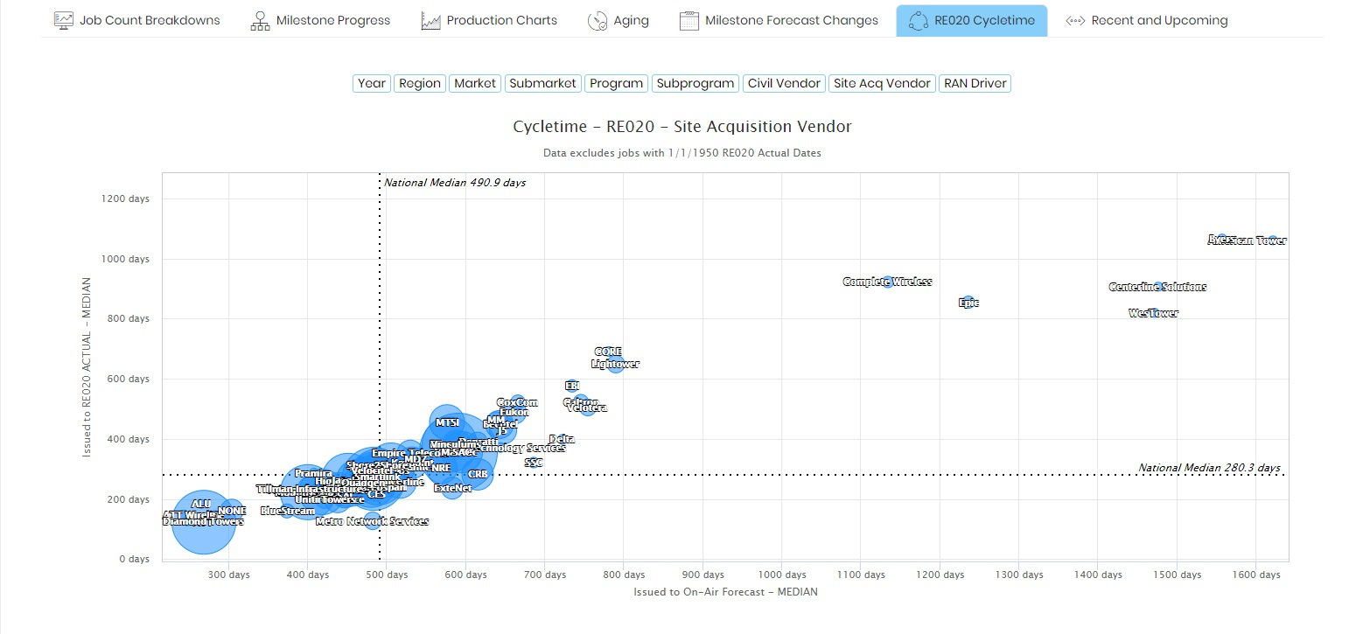

Figure 3.11 – Site Acquisition Cycletime

The bubble charts are very useful in comparing site acquisition timelines and can be reviewed by Year, Region, Submarket, Program, Subprogram, Civil Vendor, and RAN Driver. The data is also displayed in an interactive table below the chart. Users can export the data by clicking on the “CSV” or “Excel” buttons (Figure 3.12).

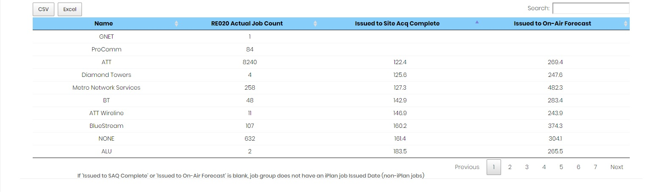

Figure 3.12 – Site Acquisition Table

Recent and Upcoming

The final tab, “Recent and Upcoming”, provides a review of work that has been completed and what is forecast to complete. Users can select which major milestone, ranging from Site Acquisition Complete to On Air Complete, from the drop-down menu. Users then select the length of time in which they would like to review the data. The selection will pull the number of projects that have been activated within that time period. It will also pull the number of projects that are forecast to complete over that same time period. If the user selects “10”, PONDER will look back and pull the projects that were completed in the last 10 days and then look at what is forecast to complete in the next 10 days. Upon selecting how to group the projects, either by Region, Market, Submarket, Program, Sub-program, Civil Vendor, Site Acquisition Vendor, or RAN Driver, a table is generated that summarizes the results (Figure 3.13).

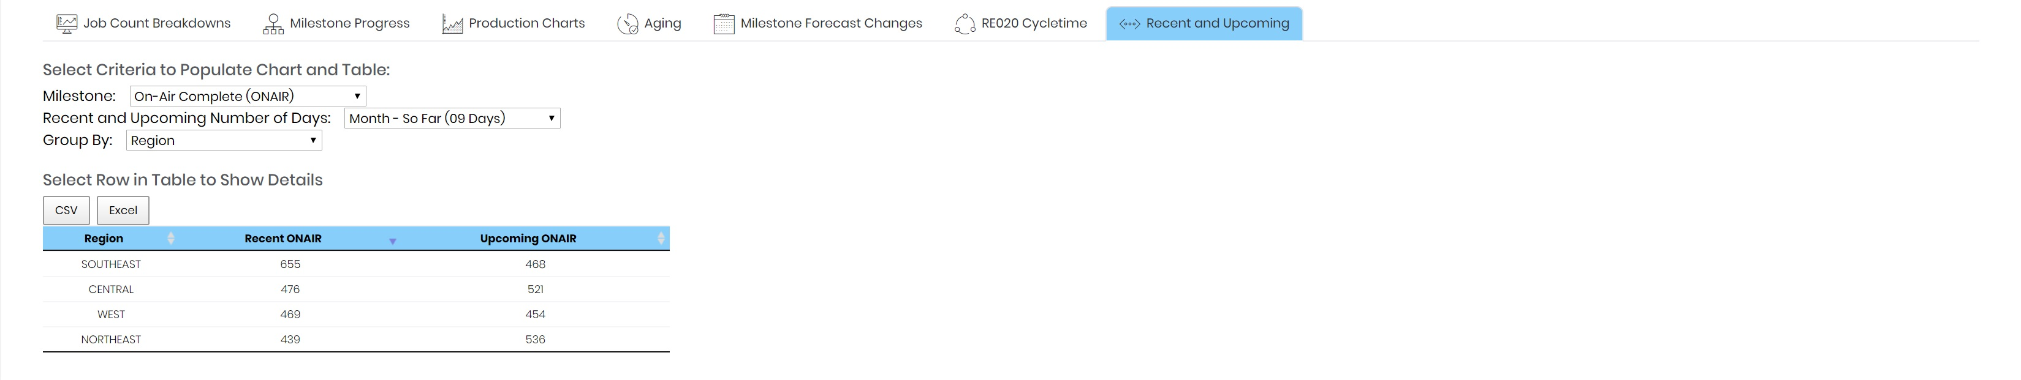

Figure 3.13 – Recent and Upcoming Results

The resulting table is a high-level summary of all the jobs associated to the filtered criteria. When the user selects a row from the table, a map is generated highlighting the locations of each projects. In this case, the user selected “SOUTHEAST” from the table to display all the results for that region. Project details can be displayed by clicking the individual rings (Figure 3.14).

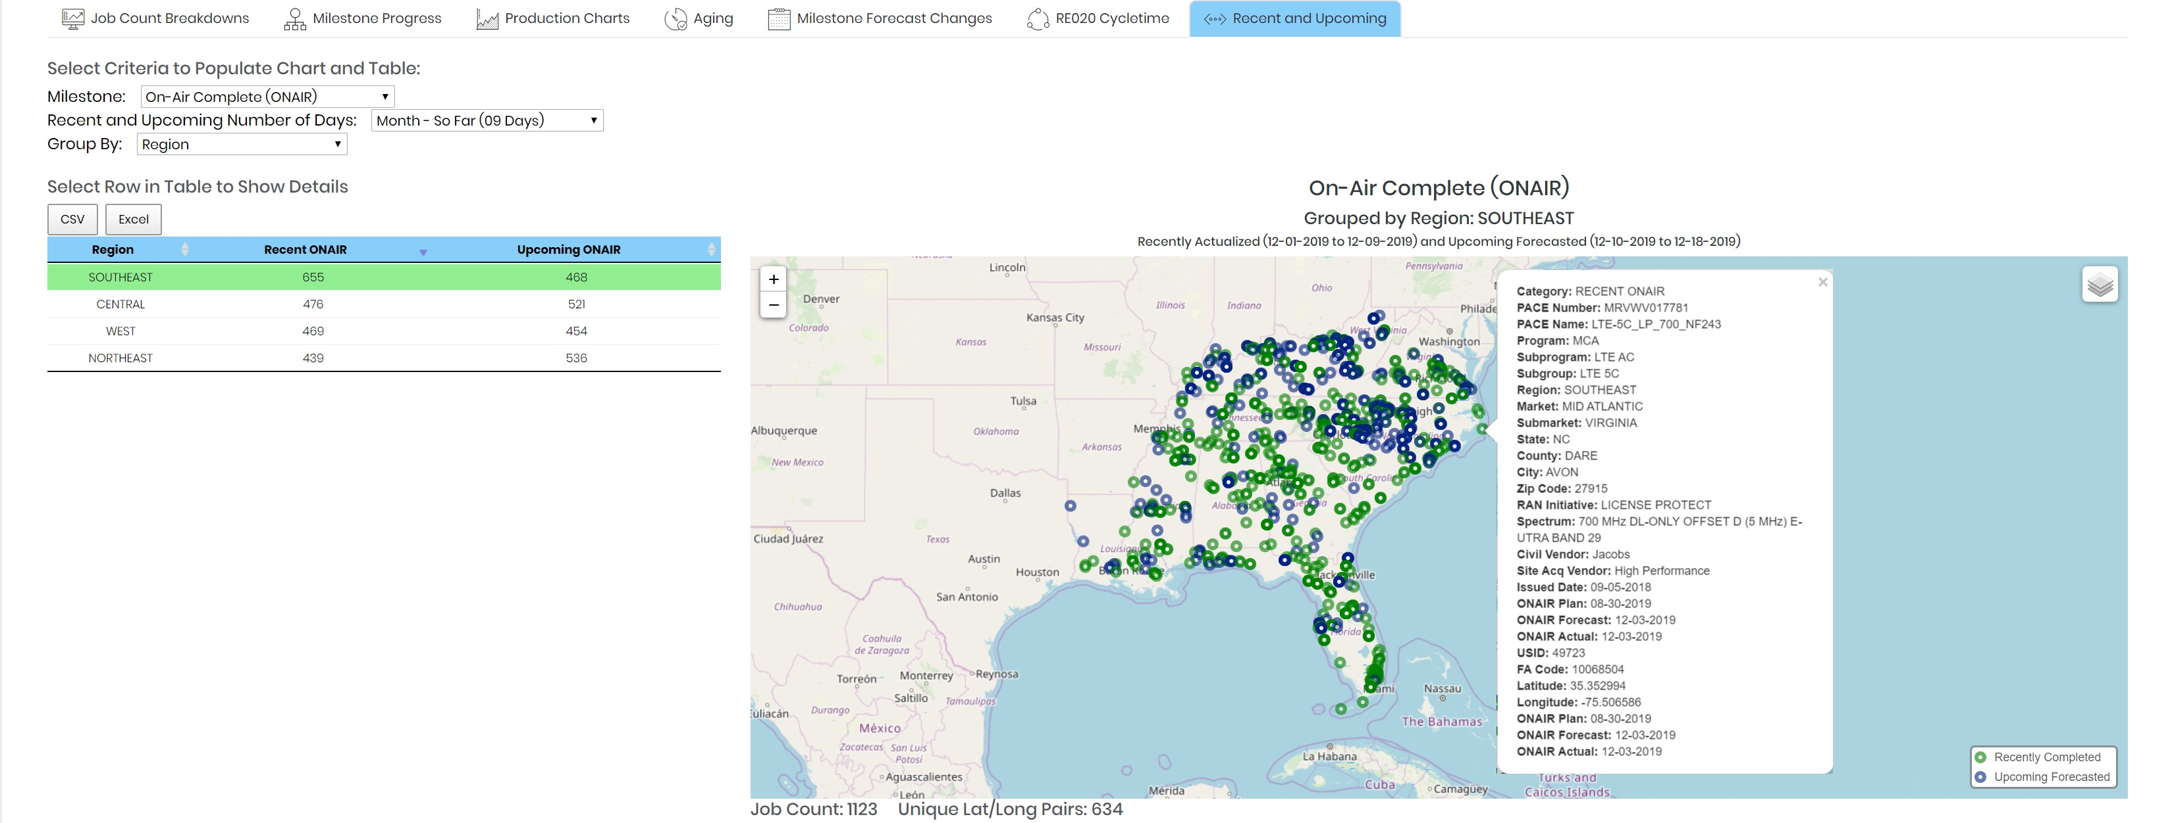

Figure 3.14 – Recent and Upcoming Results Map

An interactive table (Figure 3.15) is also generated providing additional details of each project associated to the selection. Users can modify the table utilizing the filters at the base of the table.

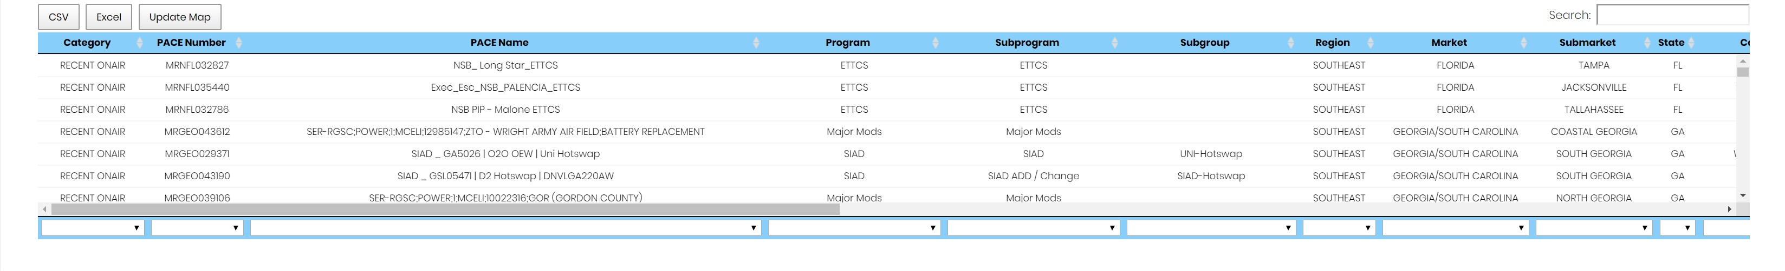

Figure 3.15 – Recent and Upcoming Results Table

Once the desired filters have been applied, users can select the “Update Map” button and a new map will be generated showing only the projects related to the filter selections. A full list of detailed project information can also be exported by clicking the “CSV” or “Excel” button.

Daily Counts Section

The Daily Counts section allows the user to track program forecasts. This feature allows users to view the project counts and see how many projects are getting pulled in or pushed out over the course of the year. Users access the Daily Count section by selecting it from the menu located on the left-hand side of the main dashboard page (Figure 4.0).



Figure 4.0 – Daily Counts Section

Upon loading the Daily Counts section, the user will choose the data to review utilizing drop-down filters related to:

* Year
  + Ability to select current year through future forecast years
* Region
  + Six RAN Regions – Central, Los Angeles, Northeast, Northern California, Southeast, and West
* Market
  + 26 RAN Markets
* Submarket
  + Each submarket associated with the 26 RAN Markets
* Program
  + Programs tied to key business initiatives (i.e. FNET NSB, Wireless Local Loop NSB, 5G NR, etc.)
* Month
  + Timeline to be reviewed ranging from monthly to full year (Limited to data from September 16th, 2019 forward)
    - Users can also review the overall project counts that have been pulled in or pushed out over the year (FULL YEAR – PUSH, FULL YEAR – PULL)

After selecting the desired filter criteria, the user will “Submit” the request and the results are displayed in an interactive chart (Figure 4.1).

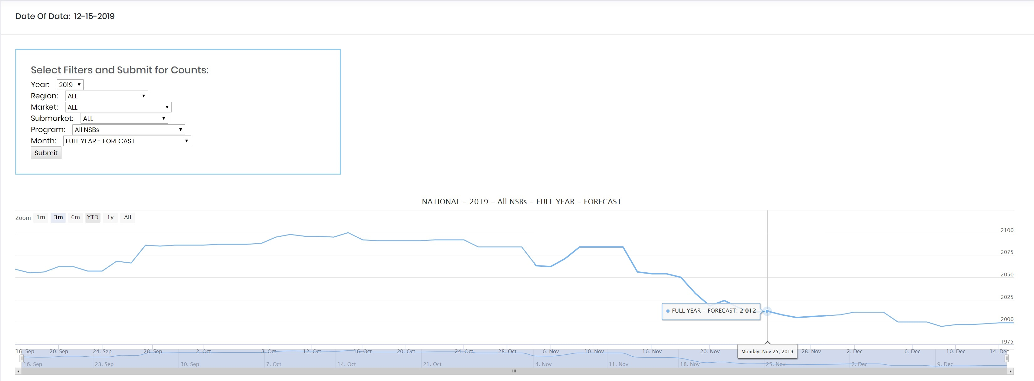

Figure 4.1 – Daily Count NSB Chart

In this chart, the user has selected to review the counts for New Site Builds forecast to be on air in 2019 for the entire nation. Users can see point data by hovering on the line in the chart as shown in Figure 4.1. The time period can be changed to 1 Month, 3 Months, 6 Months, Year to Date (YTD), 1 Year, or All views through the selection found at the top of the graph. Users can also customize the time period by manually sliding the tabs, highlighted by arrows in Figure 4.1, to the desired date.

Point data is also displayed in table form at the bottom of the web page (Figure 4.2). Users can filter to the desired day through the selection option at the end of each column or export the data set by selecting the “CSV” or “Excel” buttons.

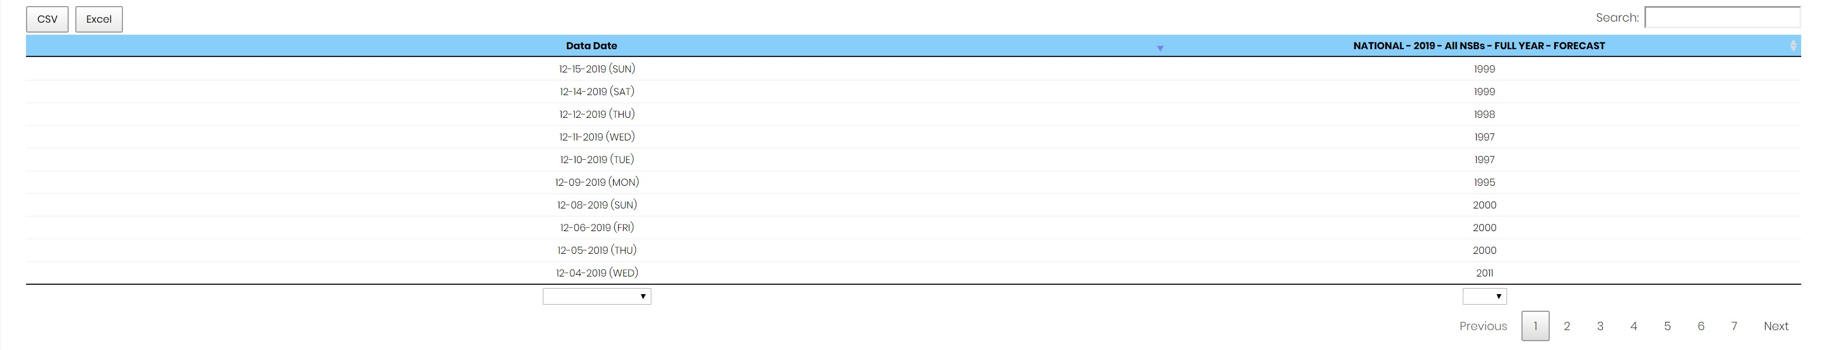

Figure 4.2 – Daily Count NSB Table